1.Church Rosser theorem

X will change

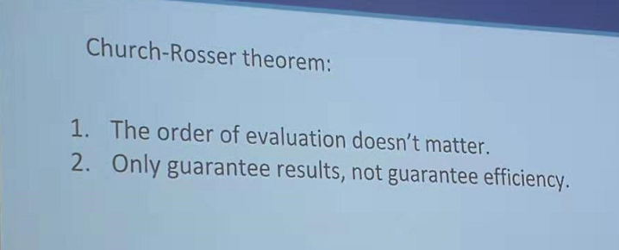

2. type of functions not required but good and important to have

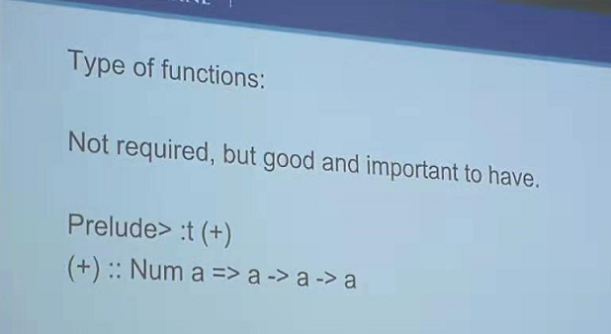

3.side effect

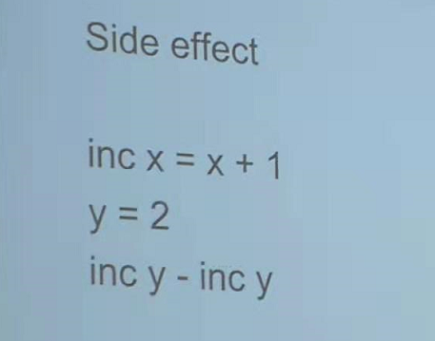

4. let x = 3

Let x = 4

There will be a error

5.no interation, always recursion

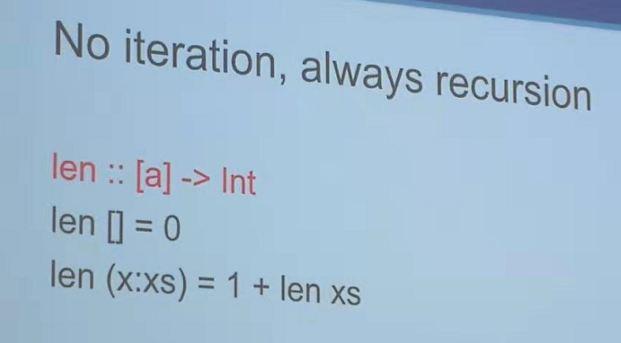

3.26

Helper function

Maybe

BST

Data TreeNode = Leaf | Node val (TreeNode a) (TreeNode b)

Preorder traversal:

Inorder

Preorder :: TreeNode Val -> [Int]

Preorder Leaf = []

Preorder Node v left right = v: preorder left ++ preorder right